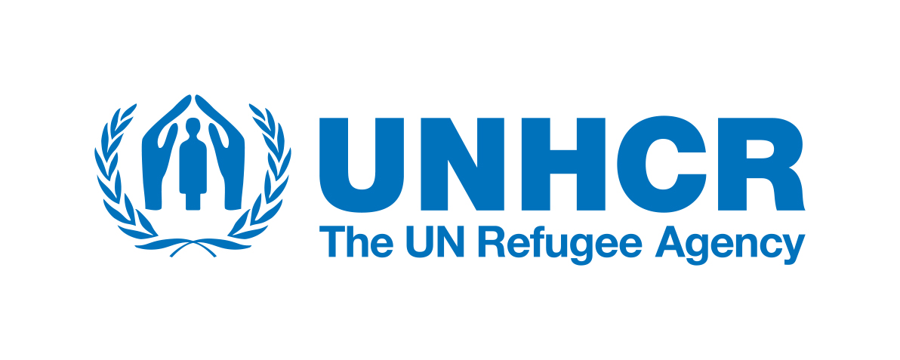

FACT SHEET 2021
FDMC in partnership with the UNHCR, the UN Refugee Agency is aiming to achieve sustainable durable solutions for the most vulnerable internally displaced persons who are residing in Collective Shelters (CSs) Kosovo wide.
To enable effective durable solutions opportunities, FDMC will work to strengthen the capacity of relevant institution to support return and reintegration initiatives and to improve access to social rights.
FDMC will closely coordinate and support the most vulnerable access to rights and services prioritisation with the target municipalities in all aspects including other partners of UNHCR and stakeholders.

MISSION
Support relevant institutions to ensure the creation of environment conducive for durable solutions, including the option of returning to place of origin, integrating in place of displacement in Kosovo subject to informed, individual and voluntary decisions of displaced persons.
FDMC will conduct needs assessments analyses in all targeted Collective Shelters and support development of a durable solutions activity plans with recommendations for each target municipalities.
In line with COVID-19 developments, FDMC will advocate for inclusion of IDPs through Social networks and On-line campaigns of displaced persons and vulnerable individuals in the initiatives that can create social and economic benefits.
Str. Cara Lazara nn Gracanica, Kosovo
Tel: +383 49 886 891
E-mail: fdmcgrac@gmail.com
Web: fdmckosovo.org

OUR ACTIVITIES
FDMC will support UN Kosovo Team Agenda and 2030/SDGs and for the benefit of displaced persons and vulnerable individuals.
In accordance with COVID-19 developments and regular activities ONLINE and in-persons focus group will be organized on regular bases in Collective Shelters.
A home-made products/handcraft exhibition with women and children will be organized with IDPs in Collective Shelters.
AIM
The overall objective of this project is to contribute to more effective achievement of sustainable durable solutions for the most vulnerable groups including internally displaced persons residing in Collective Shelters, elderly, women, youth disabled and other vulnerable persons who cannot afford to cover their specific needs based on their vulnerabilities.

VISION
FDMC main goal is to promote development of civil society, empowerment of the women, youth, marginalized groups, people with disabilities, displaced persons, connecting relevant institutions and local citizens by promoting the process of return, dialogue and reintegration.

